Title : Data Flow from Materials Management to Finance.
(Domestic Purchases)

Important Information which can be seen from Purchase Order

Transaction code ME23 -- The system will display “Display Purchase Order – Initial Screen”. Here we should enter the purchase order number.

The screen is shown below with document number of Purchase Order.

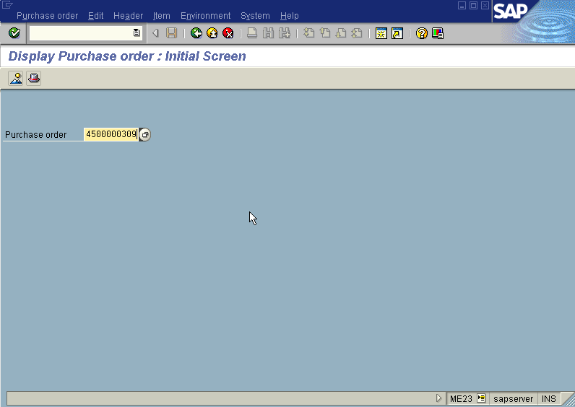

Press Enter button

The System displays “ Display Purchase Order – Item Overview” Screen indicating the line item details of the purchase order as below For eg; in this case Sacchrin insoluble details.

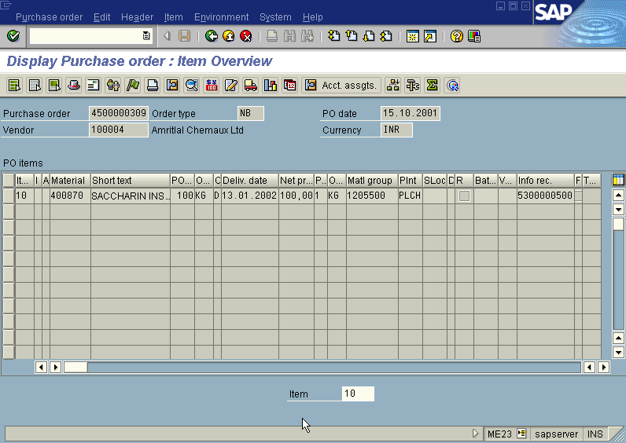

In the above “ Display Purchase Order – Item Overview” screen, select the respective line item and click Item Details.

Then we get the “Display Purchase Order – Item 00010” screen as below indicating the full details of the product with respect to the P.O including the Tax Code (B0 in the present case).

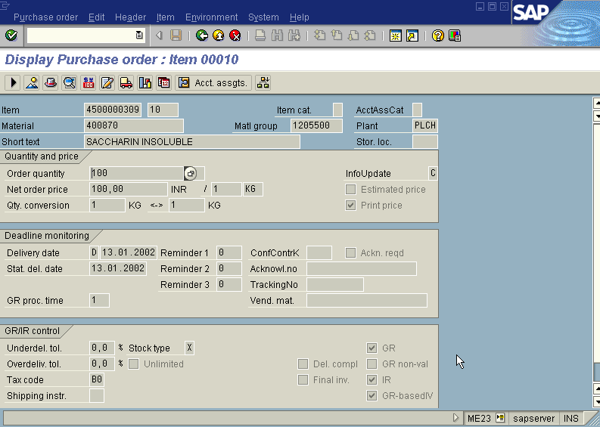

From above “Display Purchase Order – Item 00010” screen, select the respective line item and click Item More FunctionS Taxes. Then the following screen with Tax details will appear where from all tax calculation details can be had.
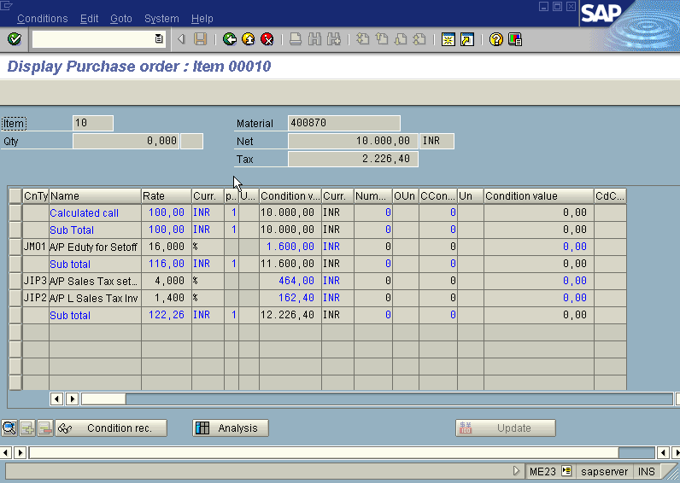
.
Go back to “Display Purchase Order – Item Overview” screen and
Press (PO History) Icon

We get “ Order History for Purchase Order” screen as below. Here we can get the status of PO regarding goods receipt, invoice verification, delivery costs (both planned & unplanned), Quantity and value etc.,

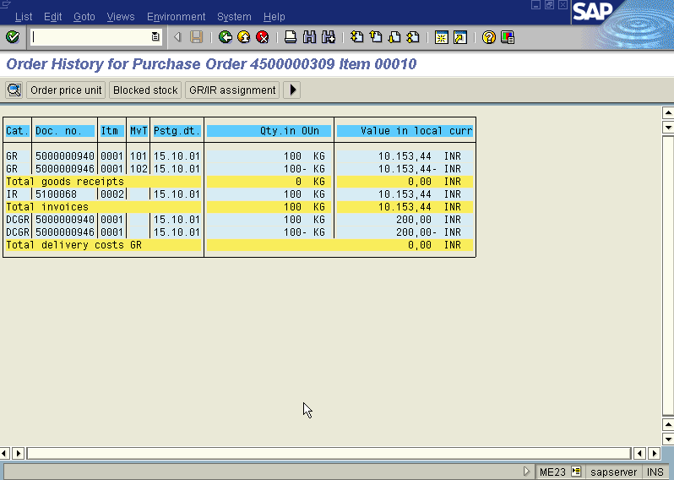

Go back to “Display Purchase Order – Item Overview” screen and
Press (item conditions) icon.

We get “ Purchase Order Display: Item- Conditions ” screen as below giving details about Gross Price of material, Freight, Cash Discount etc.

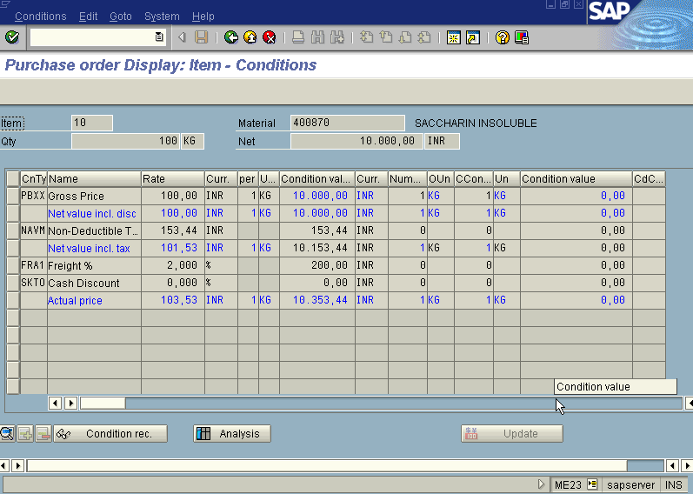

Important Points to be noted from Material Document
Transaction Code MB03

System will display“Display Material Document – Initial Screen” wherein you should enter the material document number and the year. The screen apperas as under.

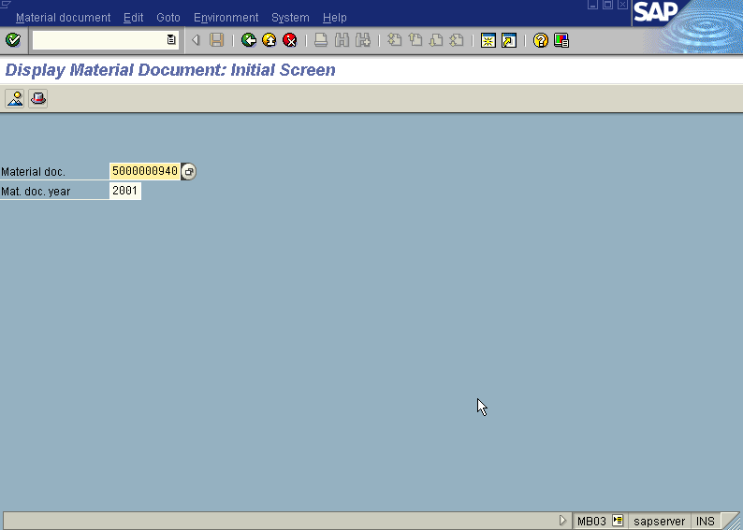

Press Enter button

We get “ Display Material Document 5000000940 : Overview” screen as below

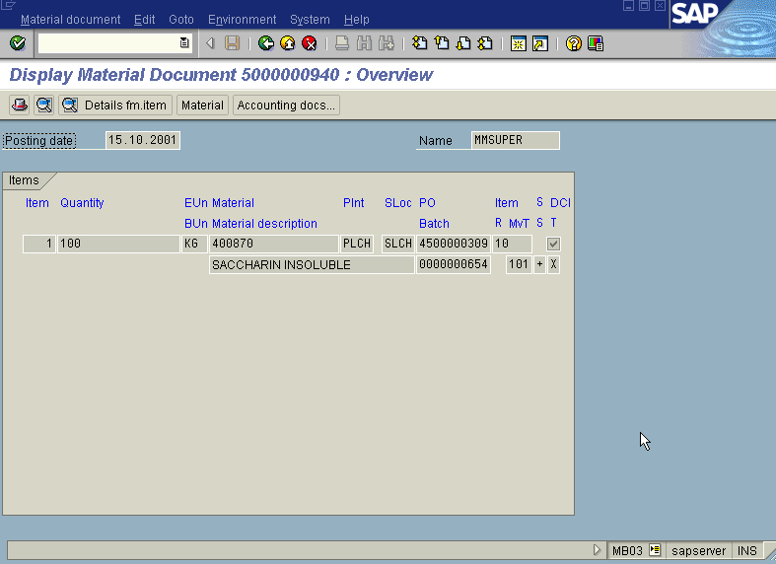

In the above screen, press button

We get the “Document Overview” screen showing the entries as under

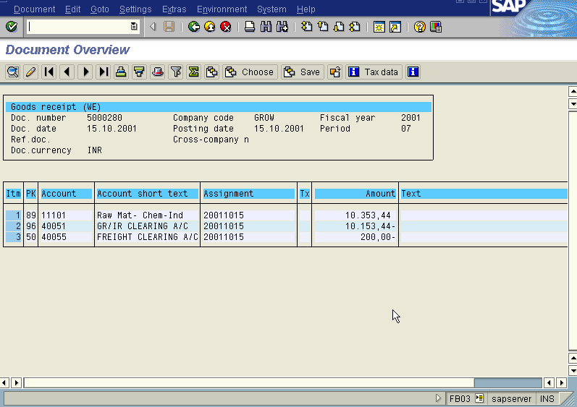

Important points to be noted from Excise Invoice

Transaction code: J1IA

We get “ Excise Invoice Create/Verification/Posting” Screen as below

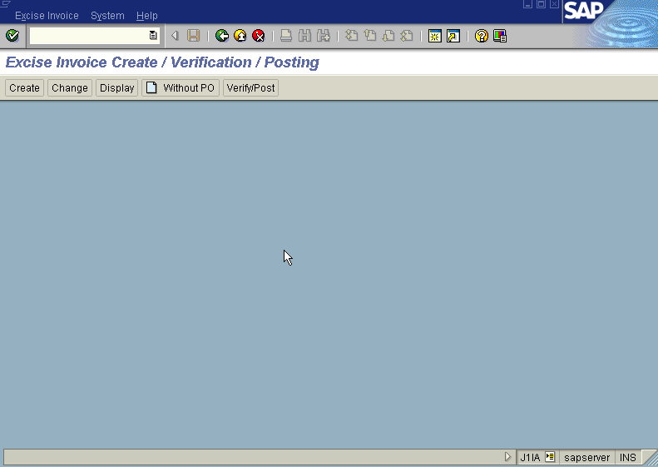

Press icon

We get the “Display Excise Invoice” screen. Here give just the Internal Excise invoice number (eg. 200001202 in this case} and then press Enter. Then automatically the system presents all the relevant info like P.O. number,Material Document number etc. Incorporating the above details the screen is displayed as under

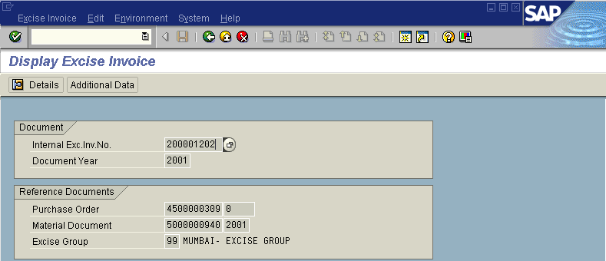
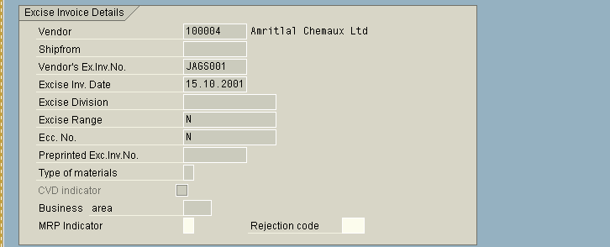

Press icon

We get “Display Excise Invoice” screen as below

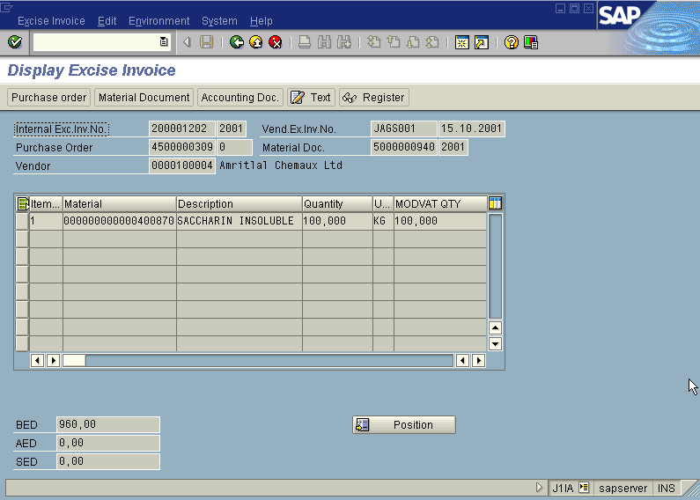

Note that the excise duty will appear in this screen.

In the above “Display Excise Invoice” screen

Press icon

We get a “Document Overview” screen giving details of entry passed as below.

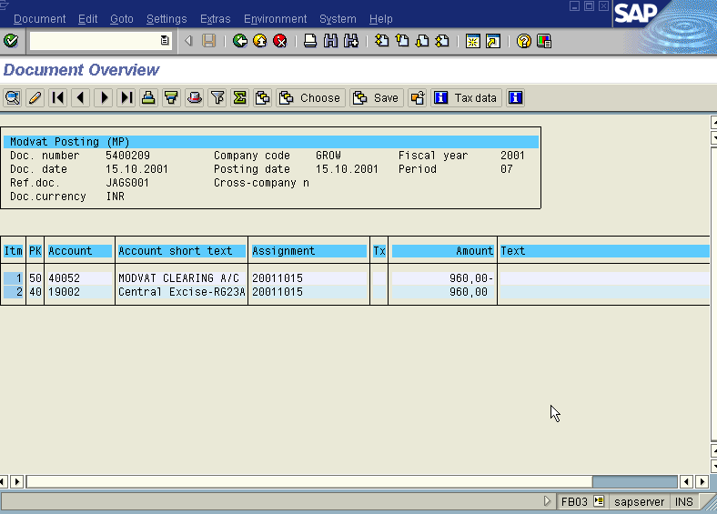

In the above accounting entry, MODVAT claim posting is recorded.

Important points to be noted from Invoice

Transaction code: MR03

We get “Display Original Document- Initial Screen” screen as Under

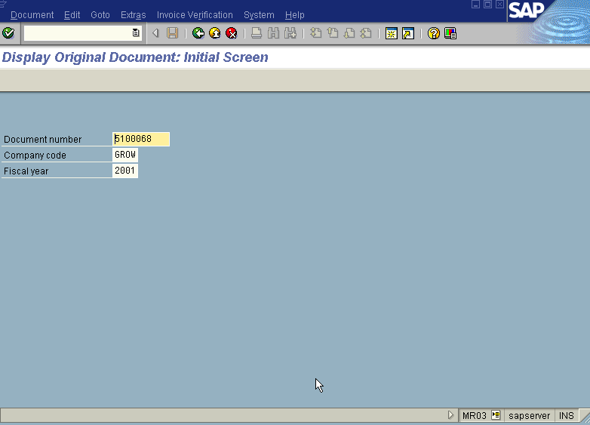

Press button

We get “Display Original Document 5100068: Document Overview in INR” screen as under

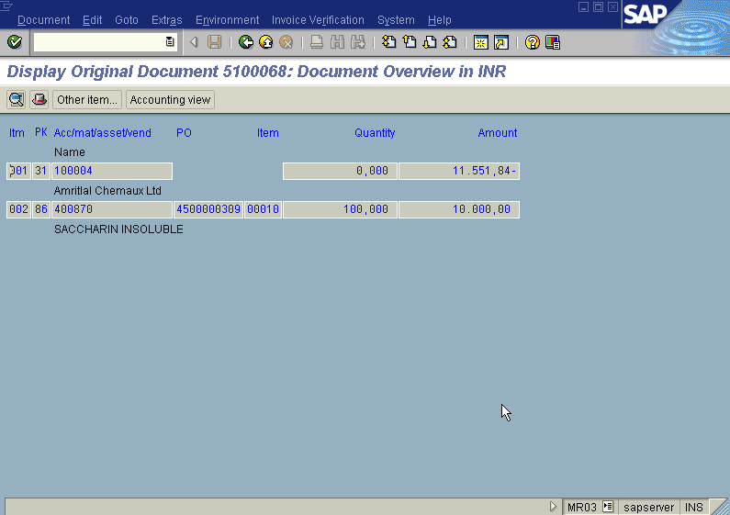

In the above screen, press icon

We get “ Document Overview” Screen with the following entries passed as under.
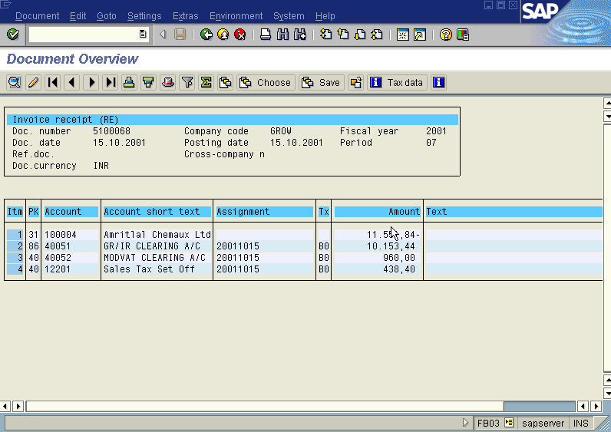

Title : Data Flow from Materials Management to Finance.
(Import Purchases)

Important Information which can be seen from Purchase Order

Transaction code ME23 -- The system will display “Display Purchase Order – Initial Screen”. Here we should enter the purchase order number.

The screen is shown below with document number of Purchase Order

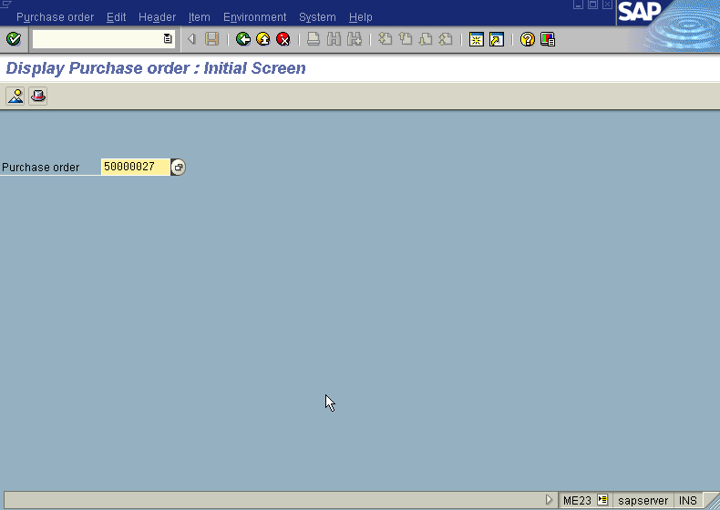

Press Enter button

The System displays “ Display Purchase Order – Item Overview” Screen indicating the line item details as below For eg; in this case Sodium Sacchrin details.

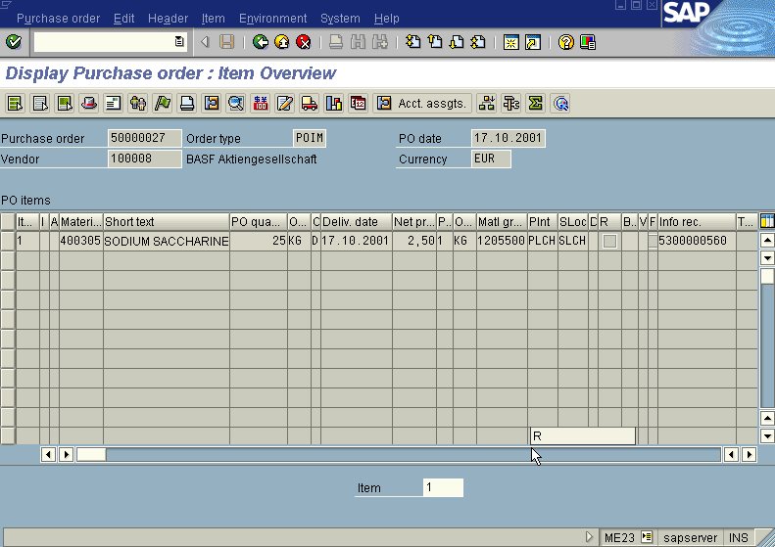

In the above “ Display Purchase Order – Item Overview” screen, we select the respective line item and click Item Details

Then we get the following “Display Purchase Order – Item 00001” screen as below indicating the full details of the product with respect to P.O. including the Tax Code (a3 in the present case).

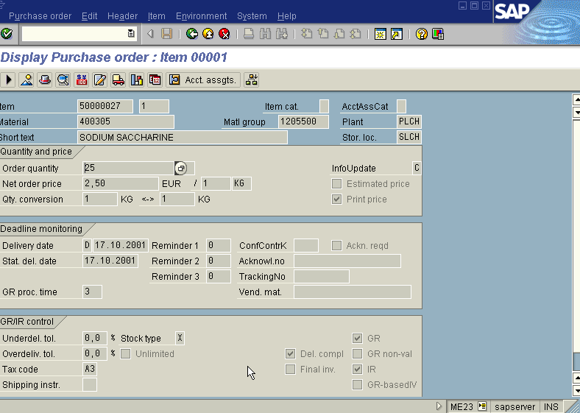

From above “Display Purchase Order – Item Overview” screen we select the respective line item and Go to the top and click Item More Functions Taxes then the following screen with Tax details will appear where from all tax calculation details can be had.
.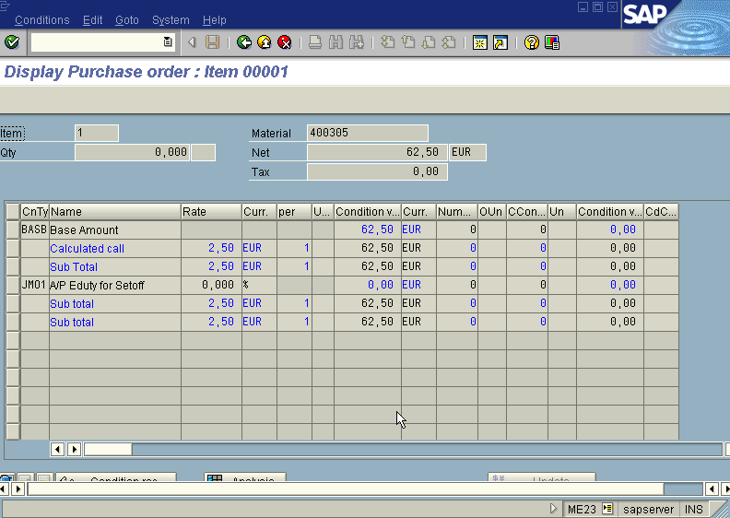
.
Go back to “Display Purchase Order – Item Overview” screen and
Press (PO History) Icon

We get “ Order History for Purchase Order” screen as below. Here we can get the status of PO regarding goods receipt, invoice verification, delivery costs (both planned & unplanned), Quantity and value etc.,

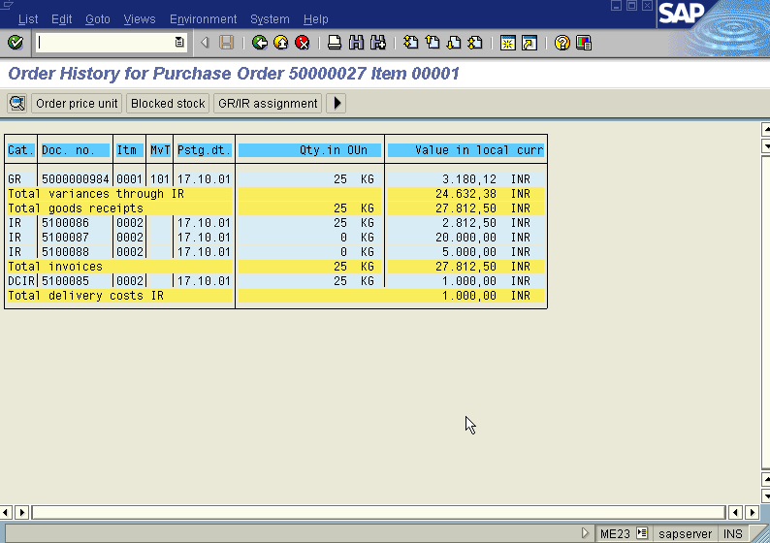

Go back to “Display Purchase Order – Item Overview” screen and
Press (item conditions) icon.

We get “ purchase order Display: Item- conditions ” screen as below giving details about Gross Price of material , CVD on material etc.

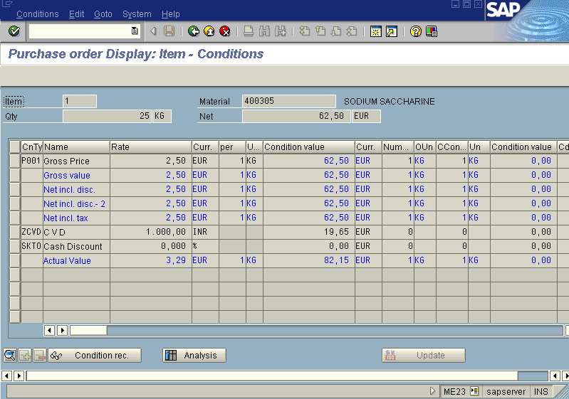

Important Points to be noted from Material Document

Transaction Code MB03

System will display“Display Material Document – Initial Screen” wherein you should enter the material document number and the year. The screen appears as under.

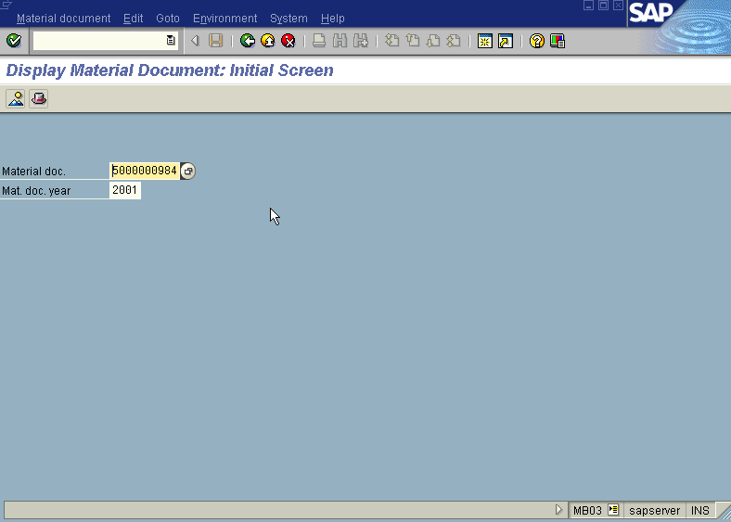

Press Enter button

We get “ Display Material Document 5000000984 : Overview” screen as below
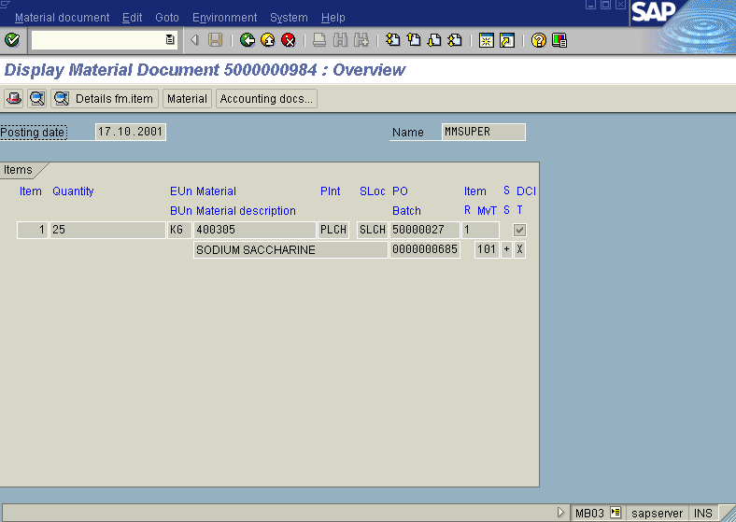

In the above “ Display Material Document 5000000984 : Overview” screen

Press button

We get the “Document Overview” screen showing the entries as under
